UJIAN AKHIR SEMESTER GENAP

**TAHUN AKADEMIK 2019/2020**

|  |  |  |  |
| --- | --- | --- | --- |
| Mata Kuliah | : | Sistem Digital | NILAI |
| Jenis Tes | : | Praktek |  |
| Prodi/Semester | : | TK/II |
| Kelas | : | 2 B |
| Nama | : | Dewi Larasati | PARAF |
| NIM | : | 19040011 |  |
| Dosen | : | Adi Candra Kusuma, M.Pd |
| Sifat | : | **Close Book** |

**Soal :**

1. Gerbang Logika dengan 2 Inputan (**Skor 65**)

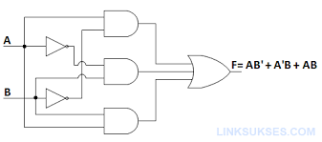

1. Buatlah Rangkaian Gerbang Logika berikut

|  |
| --- |
| $$\overline{a}$$ |

1. Buatlah Tabel Kebenaran gerbang logika tersebut!

|  |  |  |  |  |  |  |  |
| --- | --- | --- | --- | --- | --- | --- | --- |
| A | B | $$\overline{A}$$ | $$\overline{B}$$ | **A. $\overline{B}$** | $\overline{A}$.B | A.B | Y |
| 0 | 0 | 1 | 1 | 0 | 0 | 0 | 0 |
| 0 | 1 | 1 | 0 | 0 | 1 | 0 | 1 |
| 1 | 0 | 0 | 1 | 1 | 0 | 0 | 1 |
| 1 | 1 | 0 | 0 | 0 | 0 | 1 | 1 |

1. Buatlah Rangkaian Gerbang Logika dengan 3 Inputan $y=A.\overline{B}+(\overline{A+B)}.C+B.C.D$ (**Skor 35**)

|  |
| --- |
|  |

**--oOo Selamat Mengerjakan oOo--**